Overview

This document describes the creation of a Visual Basic .NET GUI used to demonstrate USART Async communication.

History

4-23-07 - Original

Requirements

- Visual Basic 2005 Express (free download from Microsoft) or Visual Studio 2005
- PICkit Serial Analyzer, firmware version 0201 or later
- PICkitS.dll software, version 1.5.0.0 or later

The example GUI in this document will be created using Visual Basic 2005 Express. If you are using Visual Studio, some pictures will vary slightly.

Project creation and dll linking

- Open Visual Basic Express and create a new Windows project (File -> New Project -> Windows Application.
- Name the project USARTExample.
- In the Solution Explorer (upper right corner), select the project USARTExample, then press the “Show All Files” button to reveal all files.

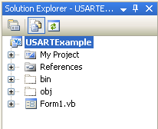

- Right click on References and select ‘Add Reference’ to add the PICkit Serial DLL.
- Select the Browse Tab and navigate to PICkitS.dll and select it. (If you have PICkit Serial Analyzer installed, you can find the dll at C:\Program Files\Microchip\PICkit Serial Analyzer). This allows the GUI to have access to functions embedded in the dll.
- The Solution Explorer should now look like this:
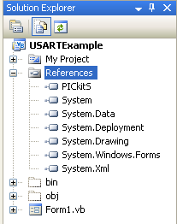

For this example GUI we will not use a separate board to talk to. Instead we will cause the PICkit Serial Analyzer to echo back USART data we send to it.

- Using a compatible male connector, short out the RX and TX pins of the PICkit Serial Analyzer.

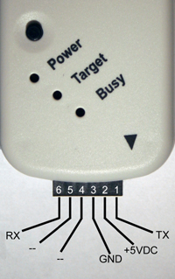

Data Transmission and Manual Read

- Enlarge the Form a bit and add the following items:

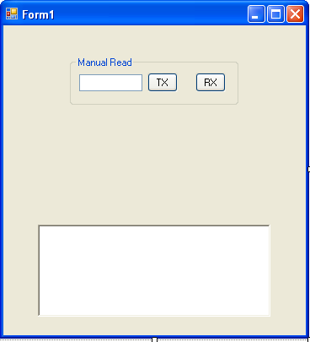

- A textbox, two buttons, and a groupbox to hold them all
- A richtextbox to display data

- Change the text for the buttons and groupbox to match the picture above by selecting each and changing the Text in the Properties (lower right corner of IDE)

- Rename the objects per below by selecting each object, then changing the Name in the Properties (lower right corner of IDE):

  - TextBox_TX
  - Button_TX
  - Button_RX
  - RichTextBox_Display

The groupbox does not need to be renamed.

Now let’s add some initialization code to the form. This will set up the dll properly, configure the PICkit Serial Analyzer for USART communication, and inform the user of the initialization status.

- Click on the Form in the [Design] tab, and double click the Title bar at the top of the form. This will create a function Form1_Load. Inside this function, type the following:

Private Sub Form1_Load(ByVal sender As System.Object, ByVal e As System.EventArgs) Handles MyBase.Load
If (PICkitS.Device.Initialize_PICkitSerial()) Then
If (PICkitS.USART.Configure_PICkitSerial_For_USARTAsync()) Then
RichTextBox_Display.Text += "PICkit Serial correctly configured for USART Async" & vbCrLf
Else
RichTextBox_Display.Text += "Error configuring PICkit Serial for USART Async" & vbCrLf
End If
Else
RichTextBox_Display.Text += "Error initializing PICkit Serial" & vbCrLf
End If
End Sub

Note – when you finish typing ‘PICkitS’ and type the ‘.’ A context window should open up and you can select Device by using the up/down arrows to highlight ‘Device’, then pressing the tab key to select it. Do the same with USART. and Configure_PICkitSerial_For_USARTAsync and add the parens yourself. Pretty cool! The vbCrLf adds a carriage return Line Feed.

- Now we add some cleanup code. Click on the Form in the [Design] tab and in the properties window (lower right corner) select the Events button (lightening bolt) and double click the FormClosed event. Inside that function, type:

PICkitS.Device.Cleanup()

This kills all communication threads and releases dll resources.

- From the menu, press Build -> Build USARTExample to make sure you have no errors at this point. If it does not build correctly, find and fix your errors – they are probably just typos.

- Let’s test your application – all it will do is find and initialize the PICkit Serial Analyzer. Attach the PICkit Serial Analyzer via a USB cable and Press the Start Debugging button

Your application should startup and display the status:

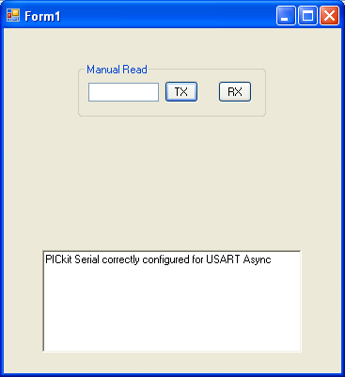

If your application does not find and configure the PICkit Serial Analyzer correctly, check your connections and verify that it is listed under Human Interface Devices in the Device Manager. If you are connecting the PICkit Serial Analyzer through a USB hub, try removing the hub and connecting directly to the PC.

- Close your application.

Now let’s add code to send some data and read the same data back when it is echoed by the PICkit Serial Analyzer.

- Double click the TX button and add this code:

Dim DataArray(256) As Byte
' will store our data here
Dim Return_Str As String = ""
' returns string representation of command - we won't use this
Dim index As Integer
' used as counter
Array.Clear(DataArray, 0, DataArray.Length)
' clear array
Dim SendData As String = TextBox_TX.Text
' get data from textbox
For index = 0 To SendData.Length - 1
DataArray(index) = Convert.ToByte(SendData(index))
' convert string data into byte array
Next
If (PICkitS.USART.Send_Data(SendData.Length, DataArray, Return_Str)) Then
RichTextBox_Display.Text += "Sent string ‘" & SendData & "’ to PICkit Serial" & vbCrLf
Else
RichTextBox_Display.Text += "Error sending data" & vbCrLf
PICkitS.Device.Reset_Control_Block() ' clear any errors in PKSA
End If

- Now double click the RX button and add this code:

Dim ByteCount As UInt32 = 0
' how many bytes are available to read
Dim index As Integer
' used as counter
Dim DataArray(256) As Byte
' will store retrieved data here
' size is arbitrary, but we must be sure not to exceed size
Dim ReturnStr As String = ""
' convert returned data from byte to string and put here
Array.Clear(DataArray, 0, DataArray.Length)
' clear array
ByteCount = PICkitS.USART.Retrieve_Data_Byte_Count()
If (ByteCount = 0) Then
' no data to read
RichTextBox_Display.Text += "No data available to read" & vbCrLf
Else
' retrieve data
If (ByteCount > DataArray.Length) Then
' oops - more data than we can hold
' either need bigger array or retrieve in chunks
RichTextBox_Display.Text += "Too much data to retrieve" & vbCrLf
Else
If (PICkitS.USART.Retrieve_Data(ByteCount, DataArray)) Then
' convert data to string for display
For index = 0 To ByteCount - 1
ReturnStr += Convert.ToChar(DataArray(index))
' convert string data into byte array
Next
RichTextBox_Display.Text += "'" & ReturnStr & "' found in PICkit Serial buffer" & vbCrLf
Else
' error retrieving data
RichTextBox_Display.Text += "Error retrieving data" & vbCrLf
PICkitS.Device.Reset_Control_Block() ' clear any errors in PKSA
End If
End If
End If

- Build your project, fix any errors and press the Start Debugging button. When the GUI appears, type some text into the textbox and press the TX button. Now press the RX button to verify the same data was retrieved from the PICkit Serial buffer:

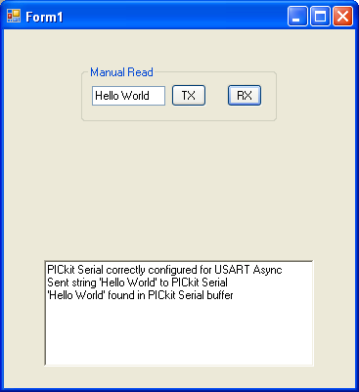

Note that in this example we are sending and displaying text. The PICkit Serial dll functions send and retrieve bytes. It is up to the user to cast the data if necessarry, as we did here.

- Press the RX button again. You should get a message saying there is no data available to read:

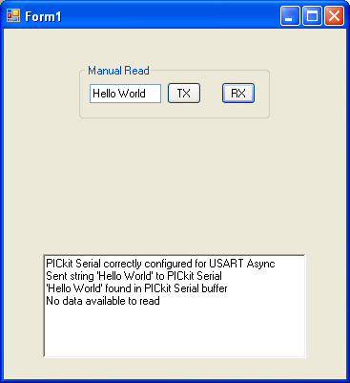

- Close your application.

The receive and transmit functions act independently from each other. That is, you can send multiple transmit commands to the PICkit Serial Analyzer and the responding data will stay in the buffer until it is read.

Automatic Data Retrieval Using a Timer

Now let’s look at a more common method of data retrieval. Rather than pressing buttons to see if data is available, we’ll automate this by using a timer.

- Add the new objects below to the form

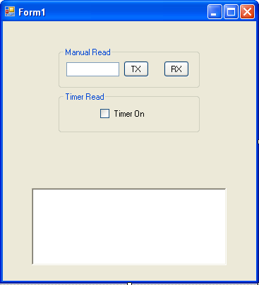

- Now add a timer to the form by dragging a timer object from the toolbox to the form. The timer will then appear below the form.

Name the checkbox and timer:

  - CheckBox_Timer
  - Timer_Read

There is no need to name the Groupbox.

- Double click the checkbox and add this code:

If (CheckBox_Timer.Checked) Then
Timer_Read.Enabled = True
Else
Timer_Read.Enabled = False
End If

- Now double click the timer and add this code:

Dim ByteCount As UInt32= 0
' how many bytes are available to read
Dim index As Integer
' used as counter
Dim DataArray(256) As Byte
' will store retrieved data here
Dim ReturnStr As String = ""
' convert returned data from byte to string and put here
Array.Clear(DataArray, 0, DataArray.Length)
' clear array
ByteCount = PICkitS.USART.Retrieve_Data_Byte_Count()
If (ByteCount <> 0) Then
' retrieve data
If (ByteCount > DataArray.Length) Then
' oops - more data than we can hold
' either need bigger array or retrieve in chunks
RichTextBox_Display.Text += "Too much data to retrieve" & vbCrLf
Else
If (PICkitS.USART.Retrieve_Data(ByteCount, DataArray)) Then
' convert data to string for display
For index = 0 To ByteCount - 1
ReturnStr += Convert.ToChar(DataArray(index))
' convert string data into byte array
Next
RichTextBox_Display.Text += "'" & ReturnStr & "' found in PICkit Serial buffer" & vbCrLf
Else
' error retrieving data
RichTextBox_Display.Text += "Error retrieving data" & vbCrLf
PICkitS.Device.Reset_Control_Block() ' clear any errors in PKSA
' turn off timer so don't keep getting error msg
Timer_Read.Enabled = False
CheckBox_Timer.Checked = False
End If
End If
End If

- Build and run your application.
- Check the Timer On checkbox to enable the timer
- Enter some text into the textbox and press the TX button.

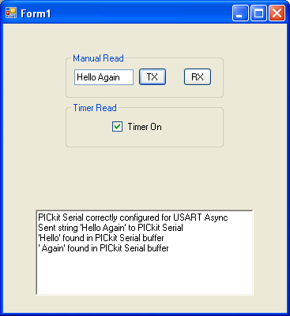
Since the GUI is polling the dll independent of any transmissions, the byte count returned by the timer function may not be what you expect. In this case, it took two Timer_Read_Ticks to retrieve all the data from the buffer. Your results may be different.

Automatic Data Retrieval Using an Event Handler

A third method of data retrieval is available. Like the timer method, it automatically retrieves data, but it is triggered the instant data is available, and does not require polling of the PICkit Serial Analyzer. It is, however, a bit more complicated to setup in the code. Here’s the theory:

When data is available in the dll buffer, an ‘event’ is triggered. During the startup of your application, you register your GUI to receive notification of this event. When you do receive an event notification, you issue the Retrieve_Data_Byte_Count and the Retrieve_Data dll calls as usual.

One complicating factor is that the new function you will create that handles this event is being triggered by another thread (the dll). The .NET platform does not allow other threads to directly update objects on forms – that is, your new function that handles this event cannot directly write to the RichTextbox. There is a work around for this problem involving a delegate that we will employ.

- Add the new objects below to the form

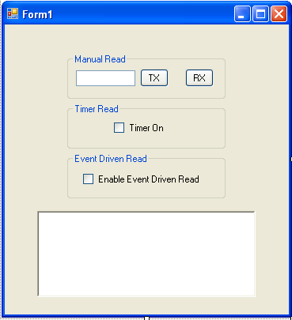

Name the checkbox as follows

  - Checkbox_Event

- Below the Form1 class defintion (below the line Public Class Form1)add the following code:

Private WithEvents DataAvailableTrigger As PICkitS.USBRead
' create event that will be triggered when data arrives
Public Delegate Sub Threaded_Textbox_Update(ByVal pText As String)
Dim DisplayResultsLock As New DataObject() ' used to lock richtextbox from multiple threads
Public Sub RegisterEvents(ByVal s As PICkitS.USBRead)
DataAvailableTrigger = s
' register event with dll
End Sub
Public Sub UnregisterEvents()
DataAvailableTrigger = Nothing
End Sub
Private Sub HandleData() Handles DataAvailableTrigger.DataAvailable
' this subroutine will be triggered by the dll when data is available
'
' only run when CheckBox_Event is checked
If (CheckBox_Event.Checked = True) Then
Dim ByteCount As UInt32 = 0
' how many bytes are available to read
Dim index As Integer
' used as counter
Dim DataArray(256) As Byte
' will store retrieved data here
' size is arbitrary, but we must be sure not to exceed size
Dim ReturnStr As String = ""
' convert returned data from byte to string and put here
Array.Clear(DataArray, 0, DataArray.Length)
' clear array
ByteCount = PICkitS.USART.Retrieve_Data_Byte_Count()
If (ByteCount = 0) Then
' no data to read
UpdateTextBox("No data available to read" & vbCrLf)
Else
' retrieve data
If (ByteCount > DataArray.Length) Then
' oops - more data than we can hold
' either need bigger array or retrieve in chunks
UpdateTextBox("Too much data to retrieve" & vbCrLf)
Else
If (PICkitS.USART.Retrieve_Data(ByteCount, DataArray)) Then
' convert data to string for display
For index = 0 To ByteCount - 1
ReturnStr += Convert.ToChar(DataArray(index))
' convert string data into byte array
Next
UpdateTextBox("'" & ReturnStr & "' from HandleData" & vbCrLf)
Else
' error retrieving data
UpdateTextBox("Error retrieving data" & vbCrLf)
PICkitS.Device.Reset_Control_Block() ' clear any errors in PKSA
End If
End If
End If
End If
End Sub
Private Sub UpdateTextBox(ByVal pText As String)
' method to for thread other than main
' form to put text in the richtextbox
If InvokeRequired Then
Dim del As New Threaded_Textbox_Update(AddressOf Me.UpdateTextBox)
' Fire and Forget
Me.BeginInvoke(del, pText)
Return
End If
SyncLock DisplayResultsLock ' allow only one thread at a time
RichTextBox_Display.Text += pText
End SyncLock
End Sub

- In your Form1_Load function, add the following lines:

Dim HandleDataTemp As PICkitS.USBRead = New PICkitS.USBRead
RegisterEvents(HandleDataTemp)

- In your Form1_FormClosed function, add the following line

UnregisterEvents()

Here’s what we’re doing. DataAvailableTrigger associates the event DataAvailable in the dll class USBRead, with your new function HandleData(). So, whenever data is available in the dll, HandleData will be called. The logic in HandleData is similar to the other functions we have written with the exception of how the data is displayed. HandleData cannot write directly to the Richtextbox, so it invokes UpdateTextBox which can handle multi-threaded calls to display the data.

- Build and run your application.
- Check the Enable Event Driven Read checkbox and enter some data into the textbox. Do not check the Timer On checkbox
- Press the TX button.
- You should get results that look like this:

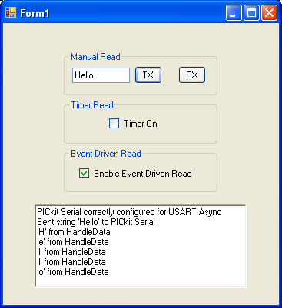

The dll event is triggered every time data is available – in this case after every byte.

- Close your application.

Baud Rate

Now, let’s look at how we change the USART baud rate.

- Add four new objects to the GUI and name them per below (you may have to increase the size of the GUI some):

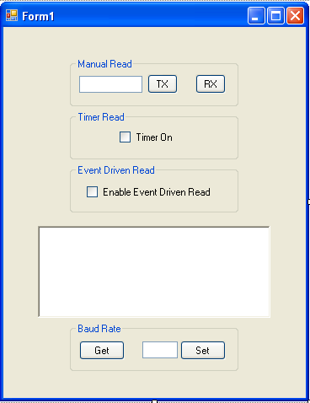

- Button_Get_Baud
- TextBox_Baud
- Button_Set_Baud

- Double click the Get Button and add the following code:

Dim Baud As UShort = 0
Baud = PICkitS.USART.Get_Baud_Rate()
If (Baud = 0) Then
RichTextBox_Display.Text += "Error retrieving baud rate" & vbCrLf
PICkitS.Device.Reset_Control_Block() ' clear any errors in PKSA
Else
RichTextBox_Display.Text += "Baud = " & Baud.ToString() & vbCrLf
End If

- Double click the Set button and add the following code:

Dim Baud As UShort
Baud = Convert.ToUInt16(TextBox_Baud.Text)
If (PICkitS.USART.Set_Baud_Rate(Baud)) Then
RichTextBox_Display.Text += "Baud Set to " & Baud.ToString() & vbCrLf
Else
RichTextBox_Display.Text += "Error setting baud" & vbCrLf
PICkitS.Device.Reset_Control_Block() ' clear any errors in PKSA
End If

- Build and run your application. Click the Get button to display the USART baud rate (the initialization routine should have set it to 1220).

- Now change the baud rate by entering a different number into the textbox then pressing the Set button. Verify the change by pressing the Get button again. (Note – the baud rate must be in the range of 77 <= Baud <= 5000000). The value you read back may not match exactly the value you entered due to rounding in the PICkit Serial firmware.

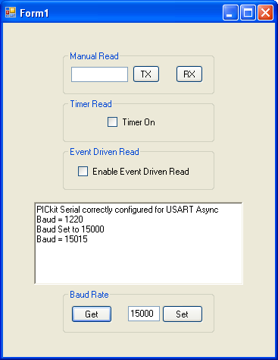

Source Voltage

Now, let’s look at how we change the USART Source Voltage. There are two options for the source voltage. You can tell PICkit Serial Analyzer you will power your device with an external voltage source, or you can tell the PICkit Serial Analyzer to power your device within a 0.0V to 5.0V range.

- Add five new objects to the GUI and name them per below (you may have to increase the size of the GUI some):

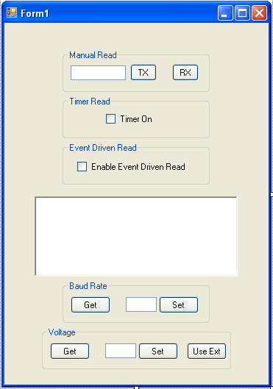

- Button_Get_Volt
- Button_Set_Volt
- Button_Use_Ext_Volt
- TextBox_Volt

- Double click the Get Button and add the following code:

Dim Volt As Double = 0
Dim PKSA_Power As Boolean
If (PICkitS.USART.Get_Source_Voltage(Volt, PKSA_Power)) Then
RichTextBox_Display.Text += "Source voltage set to " & String.Format("{0:0.0}V", Volt) & vbCrLf & "PKSA powering device is set to " & PKSA_Power.ToString() & vbCrLf
Else
RichTextBox_Display.Text += "Error retrieving source voltage" & vbCrLf
PICkitS.Device.Reset_Control_Block() ' clear any errors in PKSA
End If

- Double click the Set button and add the following code:

Dim Volt As Double
Volt = Convert.ToDouble(TextBox_Volt.Text)
If (PICkitS.USART.Set_Source_Voltage(Volt)) Then
RichTextBox_Display.Text += "Voltage Set to " & Volt.ToString() & vbCrLf
Else
RichTextBox_Display.Text += "Error setting Voltage" & vbCrLf
PICkitS.Device.Reset_Control_Block() ' clear any errors in PKSA
End If

- Double click the Use Ext button and add the following code:

If (PICkitS.USART.Tell_PKSA_To_Use_External_Voltage_Source()) Then
RichTextBox_Display.Text += "PKSA set to use external voltage source" & vbCrLf
Else
RichTextBox_Display.Text += "Error telling PKSA to use external voltage source" & vbCrLf
PICkitS.Device.Reset_Control_Block() ' clear any errors in PKSA
End If

- Build and run your application. Click the Get button to display the USART voltage (the initialization routine should have set it to ~5 volts and PKSA should be powering the device).

- Now change the voltage by entering a different number into the textbox then pressing the Set button. Verify the change by pressing the Get button again. (Note – the voltage must be in the range of 0.0 <= voltage <= 5.0). The value you read back may not match exactly the value you entered due to rounding in the PICkit Serial firmware.

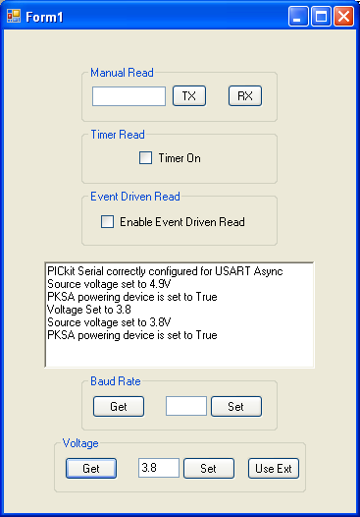

- Now press the Use Ext button and then the Get button again. The voltage should be zero and PKSA powering your device should be set to false.

AUX Status

Finally, let’s look at USART Auxilary lines. We can cotrol the state and direction of Aux lines 1 and 2.

- Add seven new objects to the GUI and name them per below (you may have to increase the size of the GUI some):

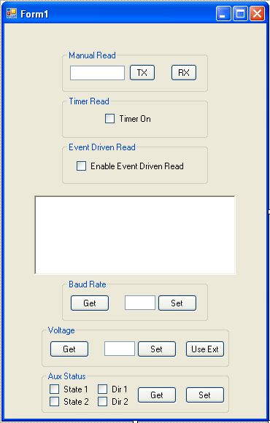

- Button_Get_Aux_Status
- Button_Set_Aux_Status
- CheckBox_State_1
- CheckBox_State_2
- CheckBox_Dir_1
- CheckBox_Dir_2

- Double click the Get Button and add the following code:

Dim Aux1_State, Aux1_Dir, Aux2_State, Aux2_Dir As Boolean
If (PICkitS.USART.Get_Aux_Status(Aux1_State, Aux2_State, Aux1_Dir, Aux2_Dir)) Then
CheckBox_State_1.Checked = Aux1_State
CheckBox_State_2.Checked = Aux2_State
CheckBox_Dir_1.Checked = Aux1_Dir
CheckBox_Dir_2.Checked = Aux2_Dir
RichTextBox_Display.Text += "Retrieved Aux status" & vbCrLf
Else
RichTextBox_Display.Text += "Error retrieving Aux status" & vbCrLf
PICkitS.Device.Reset_Control_Block() ' clear any errors in PKSA
End If

- Double click the Set button and add the following code:

Dim Result As Boolean = False
If (PICkitS.USART.Set_Aux1_Direction(CheckBox_Dir_1.Checked)) Then
If (PICkitS.USART.Set_Aux2_Direction(CheckBox_Dir_2.Checked)) Then
If (PICkitS.USART.Set_Aux1_State(CheckBox_State_1.Checked)) Then
If (PICkitS.USART.Set_Aux2_State(CheckBox_State_2.Checked)) Then
Result = True
End If
End If
End If
End If
If (Result = True) Then
RichTextBox_Display.Text += "Aux status set" & vbCrLf
Else
RichTextBox_Display.Text += "Error setting Aux status" & vbCrLf
PICkitS.Device.Reset_Control_Block() ' clear any errors in PKSA
End If

- Now build and execute your application. Try changing the state and direction of the aux lines using the set button and then confirming the change by using the get button. (Note – the state of the aux lines may float high if the direction is set to input (true) and PKSA is set to power the device – even if the state was not set.

Other Functions

It is worth mentioning a few other functions not used in the accompanying example project. See PICkitS Function Prototypes.doc for more details.

The functions below are part of class PICkitS.USART

public static bool Configure_PICkitSerial_For_USARTAsync(bool p_aux1_def,
bool p_aux2_def,
bool p_aux1_dir,
bool p_aux2_dir,
bool p_rcv_dis,
double p_voltage)

Overrides Configure_PICkitSerial_For_USARTAsync() to include options for aux status, an option to set async receive disable, and source voltage

public static bool Configure_PICkitSerial_For_USARTSyncMaster ()

Used to configure PICkit Serial Analyzer for Synchronous Master USART communication

public static bool Configure_PICkitSerial_For_USARTSyncMaster
(bool p_aux1_def,
bool p_aux2_def,
bool p_aux1_dir,
bool p_aux2_dir,
bool p_clock_pol

Overrides Configure_PICkitSerial_For_USARTSyncMaster() to include options for aux status, and an option to set clock polarity.

public static void Flash_LED1_For_2_Seconds()

Found in PICkitS.Device – can be called anytime to flash LED1 for approximately 2 seconds. Used to verify communication with PICkit Serial Analyzer. Flashing will stop on its own – there is no function call to stop flashing.

public static void Set_Script_Timeout(int p_time)

Found in PICkitS.Device – When sending any script to the PICkit Serial Analyzer, the dll will wait for the script to complete and then verify there were no status errors. The script timeout is the maximum time the dll will wait for the script to finish. The default value is 1000 (one second).

public static bool There_Is_A_Status_Error(ref uint p_error)

This function is in PICkitS.Status and can be used to get detailed error information. You would call this function after an error, but before the

PICkitS.Device.Reset_Control_Block() function call.

Note – whenever you call PICkitS.Device.Reset_Control_Block(), Baud rate, and aux status may get reset to default values. A good practice is to create a setup function in your application that sets all of the parameters you are interested in – then call that function from the Form1_Load routine and everytime you get an error from the PICkit Serial Analyzer.

